* **PRODUCT TABLE**

SQL> DESC PRODUCT;

Name Null? Type

----------------------------------------- -------- ----------------------------

PRDID NOT NULL CHAR(5)

PRDNAME NOT NULL VARCHAR2(30)

QUANTITY NOT NULL NUMBER(7)

TYPE NOT NULL VARCHAR2(50)

PRICE NOT NULL NUMBER(7)

FEATURES NOT NULL VARCHAR2(50)

AVAILABILITY NOT NULL VARCHAR2(5)

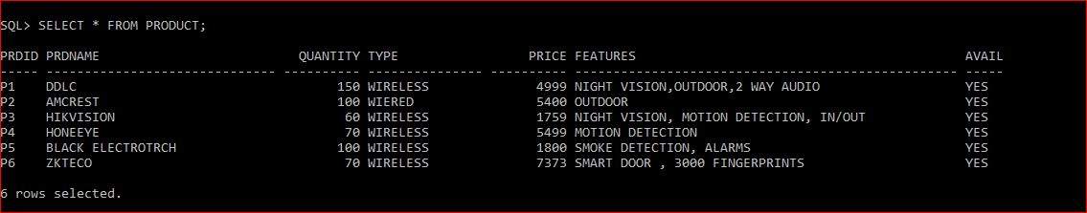

* **EMPLOYEE TABLE**

SQL> DESC EMPLOYEE;

Name Null? Type

--------------------------------- -------- ----------------------------

EMPID NOT NULL CHAR(6)

NAME NOT NULL VARCHAR(15)

CONC NOT NULL NUMBER(13)

SAL NOT NULL VARCHAR(7)

EMAIL NOT NULL VARCHAR(20)

COMM NOT NULL VARCHAR(5)

ADDRESS NOT NULL VARCHAR(20)

DOJ NOT NULL DATE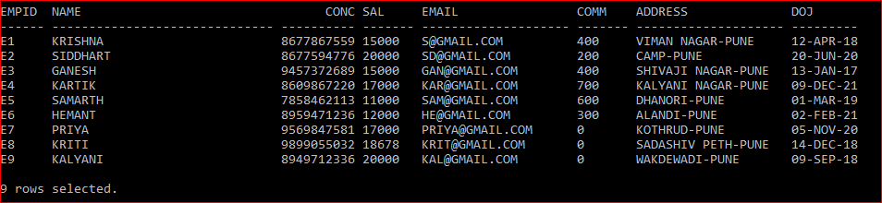________________________________________________________________________________________________________

* **MER TABLE (MERCHANT)**

Name Null? Type

---------------- --------------------- -------- -------------------------------------------

CMPID NOT NULL CHAR(5)

CMPN NOT NULL VARCHAR2(10)

OWNERID NOT NULL CHAR(5)

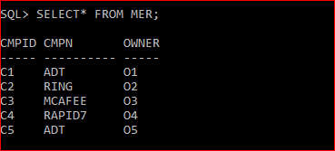

* **BUYER TABLE**

Name Null? Type

-----------------------------------------------------------------------------

BID NOT NULL CHAR(5)

ORDID NOT NULL CHAR(5)

PRDID NOT NULL CHAR(5)

EMPID NOT NULL CHAR(6)

BNAME NOT NULL VARCHAR2(10)

BCONC NOT NULL NUMBER(13)

BEMAIL NOT NULL VARCHAR2(15)

BADD NOT NULL VARCHAR2(30)

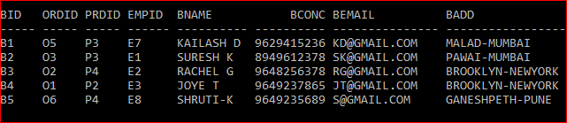

**SERVICE TABLE**

Name Null? Type

-----------------------------------------------------------------

EMPID NOT NULL CHAR(5)

BID NOT NULL CHAR(5)

PRDID NOT NULL CHAR(5)

DOI NOT NULL DATE

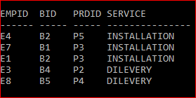

* **DELEVERY TABLE**

DESC DELIVERY;

Name Null? Type

----------------------------------------- ----------- ----------------------

ORDERID NOT NULL CHAR(5)

EMPID NOT NULL CHAR(5)

BUYERID NOT NULL CHAR(5)

PRDID NOT NULL CHAR(5)

DODL NOT NULL DATE

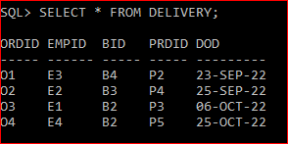

* **DEFECT TABLE**

Name Null? Type

-------------------------------------------------- ------------

PRDID NOT NULL CHAR(5)

COMPLAINTS NOT NULL VARCHAR2(30)

DEFECTS NOT NULL VARCHAR2(30)

SOLUTION NOT NULL VARCHAR2 (30) 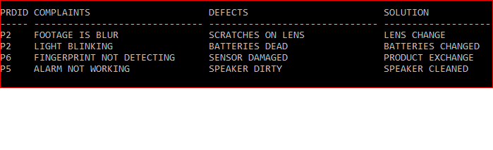

* **ORDER TABLE**

Name Null? Type

----------------------------------------- -------- ----------------------------

ORDID NOT NULL CHAR(5)

PRDID NOT NULL CHAR(5)

EMPID NOT NULL CHAR(6)

BID NOT NULL CHAR(5)

DOO NOT NULL DATE

QUANTITY NOT NULL NUMBER(6)

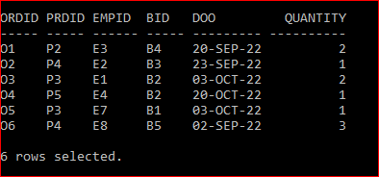

* **PAYMENT TABLE**

Name Null? Type

-------------------------------------------------------------------

PAYID NOT NULL CHAR(5)

PRDID NOT NULL CHAR(5)

ORDID NOT NULL CHAR(5)

PAYMODE NOT NULL VARCHAR2(10)

BID NOT NULL CHAR(5)

TTLAMT NOT NULL NUMBER(5)

FIRSTINST NOT NULL NUMBER(5)

PENDINGAMT NOT NULL NUMBER(5)

